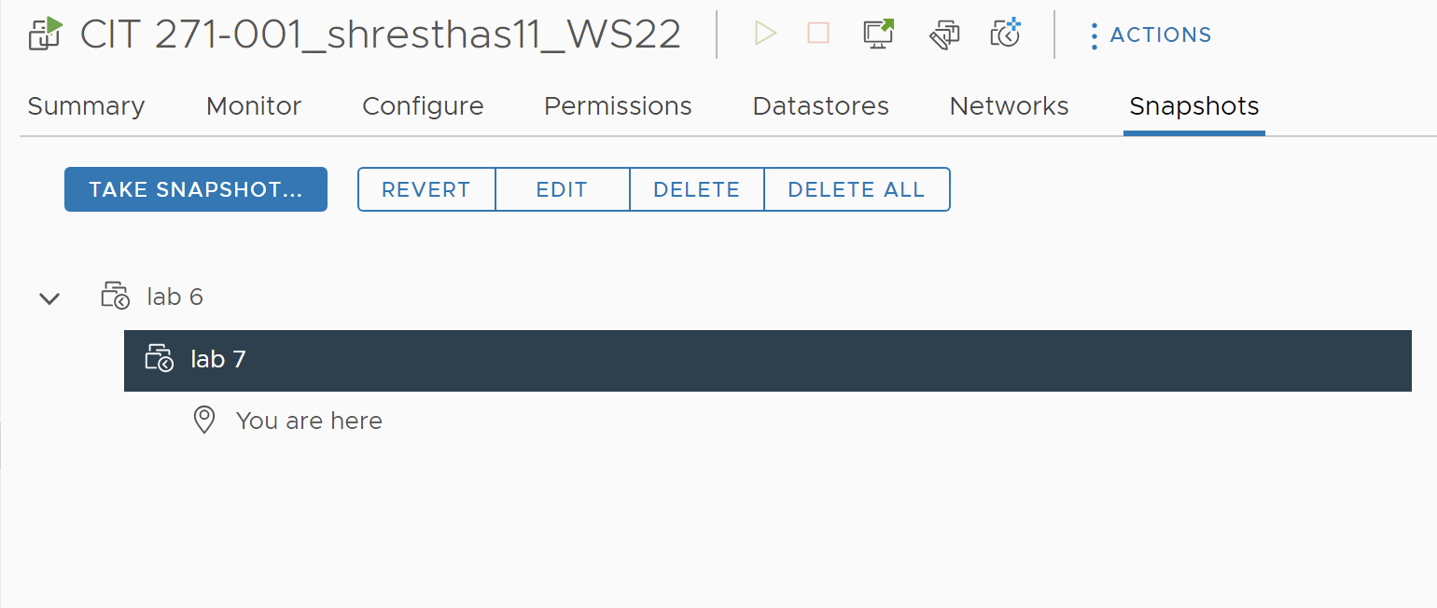

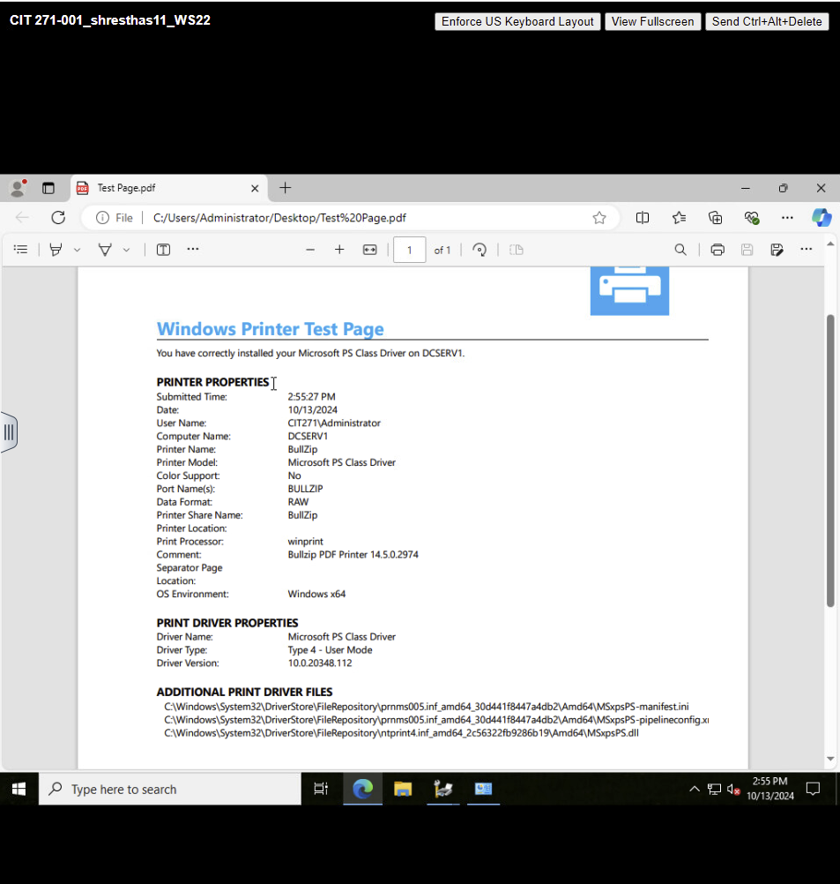

Add-Printer -ConnectionName "\\dcserv1\BullZip"

(New-Object -ComObject WScript.Network).SetDefaultPrinter("\\dcserv1\BullZip")

